COLLAGE NETWORK DESIGN



COURT ROAD NETWORKZ SYSTEMS NAGERCOIL, KANYAKUMARI

STUDENT NAME : AAKASH SARAVANAN K.V

STUDENT ID : NSNCV0722078

STAFF NAME : ANTONET REETA

COURSE NAME : CCNA

DATE : 7-12-2022

TABLE OF CONTENT

|  |  |  |
| --- | --- | --- |
| Serial.No | TITTLE | Page.No |
| 1 | Abstract | 1 |
| 2 | Acknowledgment |  |
| 3 | Introduction |  |
| 4 | Network Requirement |  |
| 5 | Hardware & software requirement |  |
| 6 | Switch & router Configuration |  |
| 7 | Network Topology |  |
| 8 | Output Results |  |
| 9 | Conclusion |  |

Abstract

The Primary purpose of a computer network is to share resources. A computer network is referred to as client/server if (at least) one of the computers is used to server other computer referred to as client. Beside the computers,other types of devices can be part of the network. In the early day of networking there will be once central server that contains the data and all the clients can access this data through a Network Interface card. Later on client server architecture came into existence, where still burden is there on the server machine. To avoid the disadvantages in distributed computing was introduced which reduce the burden on the server by providing work sharing capabilities. This paper describes how the concept of distributed computing came into existence based on the advantages and disadvantages that raised in earlier networking concepts. The concepts of distributed computing speaks that once data is available within the server (s), it should be able to be accessed and processed from any kind of client device like computer, computer, mobile phone, PDA, etc.

ACKNOWLEDGMENT

First we would like to thank the Almighty for his wonderful presence with us throughtout the completion of the project and making it as a successful one.

We are expressing our deep gratitude to COURT ROAD NETWORKZ SYSTEMS INSTITUTION which provided us an opportunity in fulfilling our most cherished desire in reaching our goal.

This is a great pleasure to express our deep sense of gratitude and thanks to our guide MISS ANTONET REETA for her valuable ideas, instantaneous help, effective support and continued encouragement which enabled for the successful completion of the project

We gratefully remember the available suggestion of our respective staff for their valuable and timely guidance for the completion of the project.

We gratefully remember the available suggestion of our respective staff for their valuable and timely guidance for the completion of this project. Finally we would like to express our sincere thanks to all our friends who gave good ideas not suggestions for our project.

INTRODUCTION

Networking is referred as connecting computers electrically for the purpose of sharing information. Resources such as a file, application, printer & software. The advantage of networking can be seen in the terms of security, efficiency, manageablility and cost as it allows collaboration between user in a wide range. The switches and router this device that play and important role in data transfer from one place to another using different technology such ad radio waves & wire.

# Networking Requirement

1. The active networking components (Routers, Switches, Wireless access points etc) with quantity.
2. The IP network design for each department.

# 3. Dynamic IP addressing design for all networks

1. Identify the configuration and features, wherever appropriate, which is required on the active components to setup the network.
2. Analysis, identification and explantion of methodologies to use for access restriction and internet sharing.
3. Creating and mapping IP networks with vlans.

# HARDWARE REQUIREMENT

* Processor AMD PRO A4-4350B R4,5 COMPUTE

CORES 2C

+3G 2.50GHz

* RAM 4.00 GB
* System Type 64-bit operating system

# REQUIREMENT

## 1. The following use cisco packet tracer to design and implement the network solution 2. Use RIP as the routing protocol 3. Configure SSH in principal room and telnet in staff room

4. Principal room, Staff room, Computer lab 1 and computer lab 2 required to have a wireless network for the users

## 5. Datascience and Multimedia should be in a different vlan 6. Class C type IP address used in every department

1. Device in Datascience and Multimedia are required to communicate with each other with the respective switch configured for intervlan routing
2. Devices in computer lab 5 are allocated IP address statically 9. Devices except computer lab 5 are allocated IP address dynamically 10. Test communication ensure everything configured is working as expected

# SOFTWARE REQUIREMENT

● CISCO Packet Tracer

# ROUTER CONFIGURATION

ROUTER 1

hostname r1

aaa new-model

aaa authentication login default group tacacs+ local

aaa authentication enable default group tacacs+ local

no ip cef

no ipv6 cef

username aakash password 0 1234

license udi pid CISCO1941/K9 sn FTX1524Z4DO-

spanning-tree mode pvst

interface GigabitEthernet0/0

ip address 1.0.0.1 255.0.0.0

duplex auto

speed auto

interface GigabitEthernet0/1

ip address 2.0.0.1 255.0.0.0

duplex auto

speed auto

interface Serial0/1/0

ip address 10.0.0.1 255.0.0.0

clock rate 2000000

interface Serial0/1/1

ip address 20.0.0.1 255.0.0.0

clock rate 2000000

interface Vlan1

no ip address

shutdown

router eigrp 1

network 10.0.0.0

network 1.0.0.0

network 2.0.0.0

network 20.0.0.0

ip classless

ip flow-export version 9

tacacs-server host 100.0.0.1

tacacs-server key cisco

line con 0

line aux 0

line vty 0 4

end

ROUTER 2

hostname r2

!

aaa new-model!

aaa authentication login default group tacacs+ local

aaa authentication enable default group tacacs+ local

no ip cef

no ipv6 cef

username aakash password 0 1234

license udi pid CISCO1941/K9 sn FTX1524B71Y-

spanning-tree mode pvst

interface GigabitEthernet0/0

ip address 3.0.0.1 255.0.0.0

duplex auto

speed auto

interface GigabitEthernet0/1

ip address 4.0.0.1 255.0.0.0

duplex auto

speed auto

interface Serial0/1/0

ip address 20.0.0.2 255.0.0.0

interface Serial0/1/1

ip address 30.0.0.1 255.0.0.0

clock rate 2000000

interface Vlan1

no ip address

shutdown

router eigrp 1

network 3.0.0.0

network 4.0.0.0

network 20.0.0.0

network 30.0.0.0

ip classless

ip flow-export version 9

tacacs-server host 102.0.0.1

tacacs-server key cisco

line con 0

line aux 0

line vty 0 4

End

Router 3

hostname Router

no ip cef

no ipv6 cef

license udi pid CISCO1941/K9 sn FTX1524ELY5-!

spanning-tree mode pvst

interface GigabitEthernet0/0

ip address 7.0.0.1 255.0.0.0

duplex auto

speed auto

interface GigabitEthernet0/1

ip address 8.0.0.1 255.0.0.0

duplex auto

speed auto

!

interface Serial0/0/0

ip address 19.0.0.2 255.0.0.0

clock rate 2000000

!

interface Serial0/0/1

no ip address

clock rate 2000000

!

interface Serial0/1/0

ip address 30.0.0.2 255.0.0.0

!

interface Serial0/1/1

ip address 40.0.0.2 255.0.0.0

clock rate 2000000

!

interface Vlan1

no ip address

shutdown

!

ip classless

!

ip flow-export version 9

!

!

!

!

tacacs-server key cisco

!

!

!

!

line con 0

!

line aux 0

!

line vty 0 4

login

!

!

!

End

ROUTER 4

hostname r4

!

aaa new-model

!

aaa authentication login default group tacacs+ local

aaa authentication enable default group tacacs+ local

no ip cef

no ipv6 cef

!

!

!

username aakash password 0 1234

!

!

license udi pid CISCO1941/K9 sn FTX15241ZSQ-

spanning-tree mode pvst

interface GigabitEthernet0/0

ip address 5.0.0.1 255.0.0.0

duplex auto

speed auto

!

interface GigabitEthernet0/1

ip address 6.0.0.1 255.0.0.0

duplex auto

speed auto

!

interface Serial0/0/0

ip address 19.0.0.2 255.0.0.0

clock rate 2000000

!

interface Serial0/0/1

no ip address

clock rate 2000000

!

interface Serial0/1/0

ip address 10.0.0.2 255.0.0.0

!

interface Serial0/1/1

ip address 40.0.0.1 255.0.0.0

!

interface Vlan1

no ip address

shutdown

!

router eigrp 1

network 5.0.0.0

network 6.0.0.0

network 10.0.0.0

network 40.0.0.0

!

ip classless

!

ip flow-export version 9

!

!

!

!

tacacs-server host 101.0.0.2

tacacs-server key cisco

!

!

!

!

line con 0

!

line aux 0

!

line vty 0 4

!

!

!

End

ROUTER 5

hostname Router

ip dhcp pool aaa

network 80.0.0.0 255.0.0.0

default-router 80.0.0.1

option 150 ip 80.0.0.1

!

!

!

ip cef

no ipv6 cef

!

!

license udi pid CISCO2811/K9 sn FTX1017F19X-

!

spanning-tree mode pvst

interface FastEthernet0/0

ip address 80.0.0.1 255.0.0.0

duplex auto

speed auto

!

interface FastEthernet0/1

no ip address

duplex auto

speed auto

shutdown

!

interface Vlan1

no ip address

shutdown

!

ip classless

!

ip flow-export version 9

telephony-service

max-ephones 5

max-dn 5

ip source-address 80.0.0.1 port 2000

auto assign 1 to 5

!

ephone-dn 1

number 1111

!

ephone-dn 2

number 2222

!

ephone-dn 3

number 3333

!

ephone-dn 4

number 4444

!

ephone 1

device-security-mode none

mac-address 00D0.FF68.3D04

type 7960

button 1:2

!

ephone 2

device-security-mode none

mac-address 000A.414E.5613

type 7960

button 1:1

!

ephone 3

device-security-mode none

mac-address 00D0.5809.4773

type 7960

button 1:4

!

ephone 4

device-security-mode none

mac-address 0001.423B.7757

type 7960

button 1:3

!

line con 0

!

line aux 0

!

line vty 0 4

login

!

!

!

end

ROUTER 6

hostname Router

!

!

aaa new-model

!

aaa authentication login default group tacacs+ local

aaa authentication enable default group tacacs+ local

!

no ip cef

no ipv6 cef

!

!

!

username aakash password 0 1234

!

!

license udi pid CISCO1941/K9 sn FTX15248807-

spanning-tree mode pvst

interface GigabitEthernet0/0

ip address 11.0.0.1 255.0.0.0

duplex auto

speed auto

!

interface GigabitEthernet0/0.23

encapsulation dot1Q 23

ip address 23.0.0.1 255.0.0.0

!

interface GigabitEthernet0/0.24

encapsulation dot1Q 24

ip address 24.0.0.1 255.0.0.0

!

interface GigabitEthernet0/1

ip address 22.0.0.1 255.0.0.0

duplex auto

speed auto

!

interface Serial0/0/0

ip address 19.0.0.1 255.0.0.0

clock rate 2000000

!

interface Serial0/0/1

no ip address

clock rate 2000000

!

interface Serial0/1/0

ip address 14.0.0.1 255.0.0.0

clock rate 2000000

!

interface Serial0/1/1

ip address 16.0.0.1 255.0.0.0

clock rate 2000000

!

interface Vlan1

no ip address

shutdown

!

router eigrp 1

network 11.0.0.0

network 19.0.0.0

network 14.0.0.0

network 16.0.0.0

!

router rip

network 11.0.0.0

network 14.0.0.0

network 16.0.0.0

network 22.0.0.0

!

ip classless

!

ip flow-export version 9

!

!

!

!

tacacs-server host 101.0.0.2

tacacs-server key cisco

!

!

!

!

line con 0

!

line aux 0

!

line vty 0 4

!

!

!

End

# SWITCH CONFIGURATION

The following configuration details the actual setup to performed on a CISCO switch.

Create VLAN’ s, VLAN 10 and VLAN 20 with respective names on switch.

Switch 1

hostname Switch

!

!

!

!

!

!

spanning-tree mode pvst

spanning-tree extend system-id

!

interface FastEthernet0/1

switchport mode trunk

!

interface FastEthernet0/2

switchport mode trunk

!

interface FastEthernet0/3

switchport access vlan 24

!

interface FastEthernet0/4

switchport access vlan 24

!

interface FastEthernet0/5

switchport access vlan 24

!

interface FastEthernet0/6

switchport access vlan 24

!

interface FastEthernet0/7

!

interface FastEthernet0/8

!

interface FastEthernet0/9

!

interface FastEthernet0/10

!

interface FastEthernet0/11

!

interface FastEthernet0/12

!

interface FastEthernet0/13

!

interface FastEthernet0/14

!

interface FastEthernet0/15

!

interface FastEthernet0/16

!

interface FastEthernet0/17

!

interface FastEthernet0/18

!

interface FastEthernet0/19

!

interface FastEthernet0/20

!

interface FastEthernet0/21

!

interface FastEthernet0/22

!

interface FastEthernet0/23

!

interface FastEthernet0/24

!

interface GigabitEthernet0/1

!

interface GigabitEthernet0/2

!

interface Vlan1

no ip address

shutdown

!

!

!

!

line con 0

!

line vty 0 4

login

line vty 5 15

login

!

!

!

!

End

SWITCH 2

hostname Switch

!

!

!

!

!

!

spanning-tree mode pvst

spanning-tree extend system-id

!

interface FastEthernet0/1

switchport mode trunk

!

interface FastEthernet0/2

switchport access vlan 23

!

interface FastEthernet0/3

switchport mode trunk

!

interface FastEthernet0/4

switchport access vlan 23

!

interface FastEthernet0/5

switchport access vlan 23

!

interface FastEthernet0/6

switchport access vlan 23

!

interface FastEthernet0/7

!

interface FastEthernet0/8

!

interface FastEthernet0/9

!

interface FastEthernet0/10

!

interface FastEthernet0/11

!

interface FastEthernet0/12

!

interface FastEthernet0/13

!

interface FastEthernet0/14

!

interface FastEthernet0/15

!

interface FastEthernet0/16

!

interface FastEthernet0/17

!

interface FastEthernet0/18

!

interface FastEthernet0/19

!

interface FastEthernet0/20

!

interface FastEthernet0/21

!

interface FastEthernet0/22

!

interface FastEthernet0/23

!

interface FastEthernet0/24

!

interface GigabitEthernet0/1

!

interface GigabitEthernet0/2

!

interface Vlan1

no ip address

shutdown

!

!

!

!

line con 0

!

line vty 0 4

login

line vty 5 15

login

!

!

!

!

End

if-range)#exit

# NETWORK TOPOLOGY

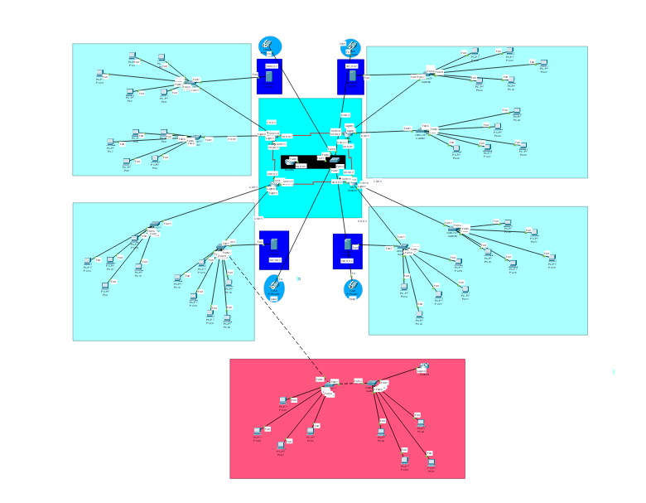

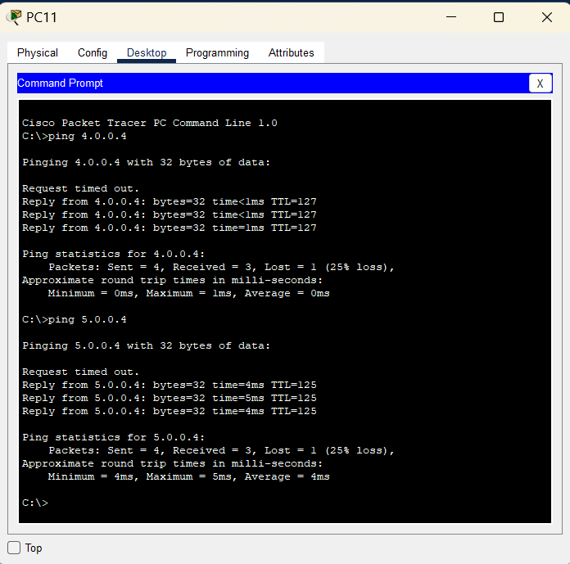

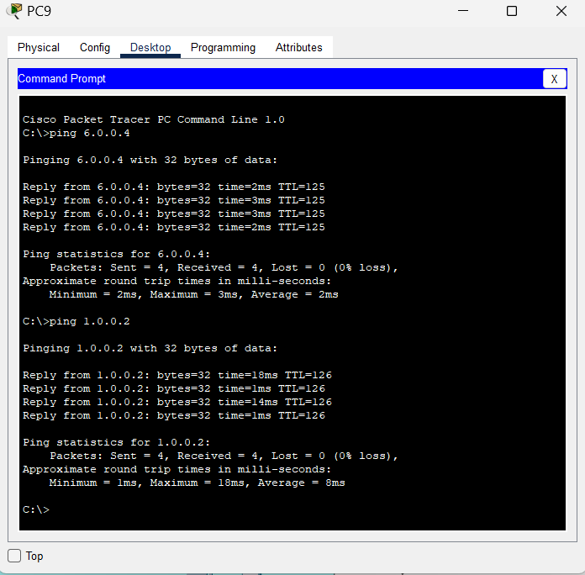

## AAA

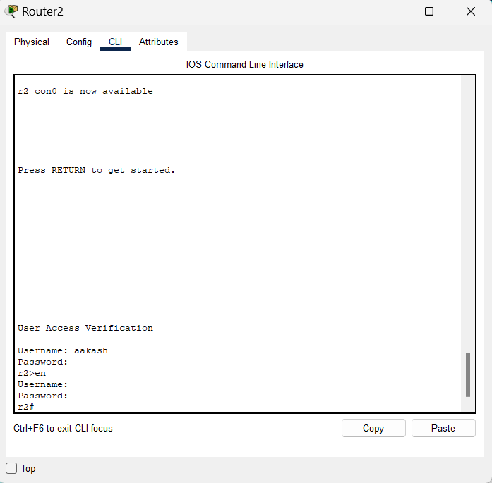

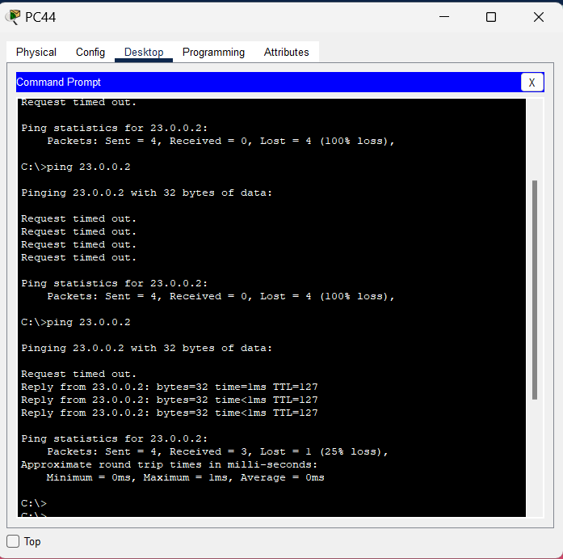

## AAA IN SERVER

## WIRELESS ACCE

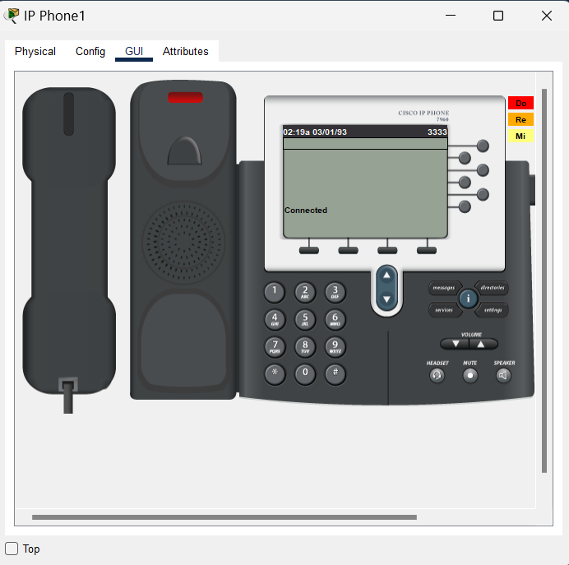

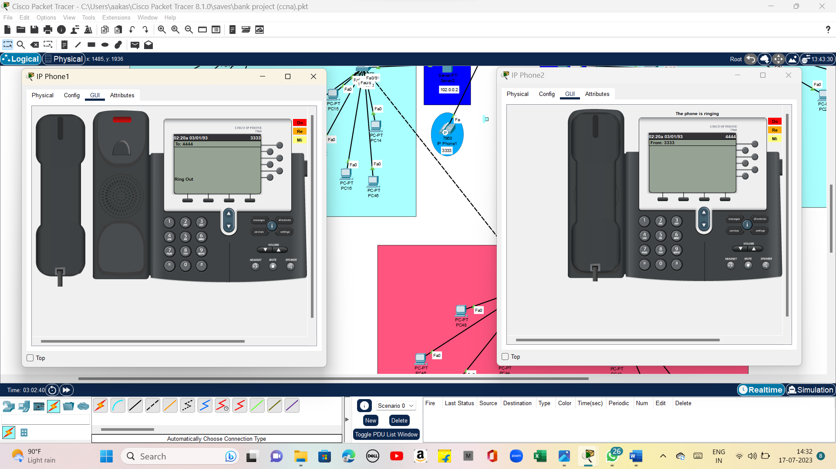

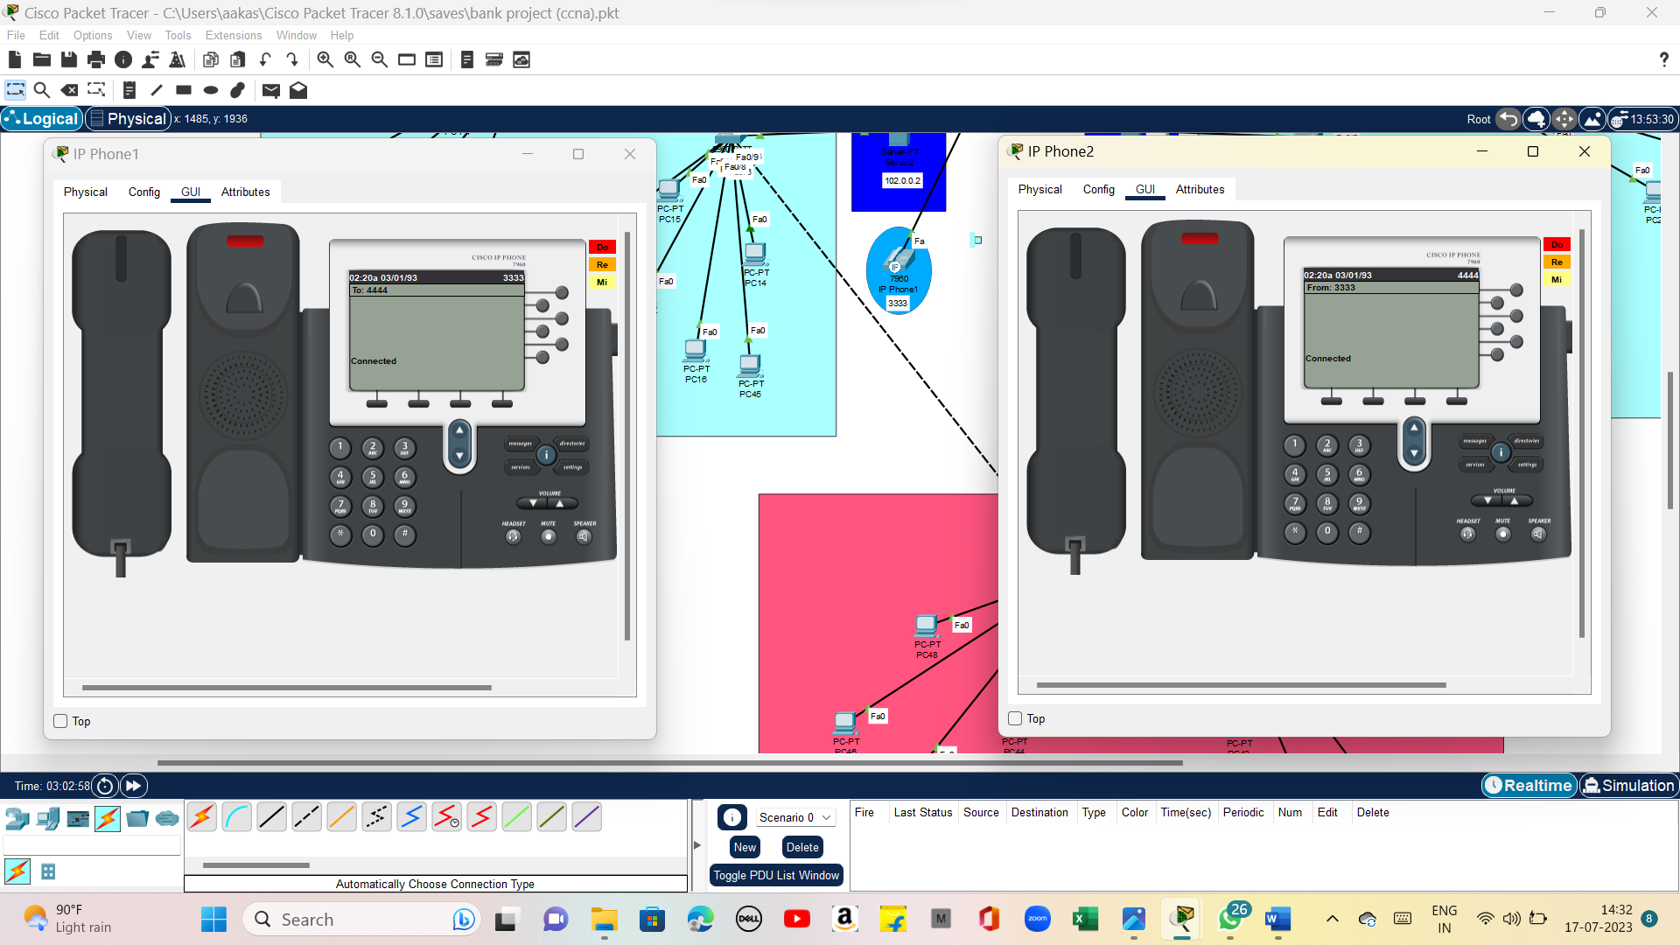

## SSPOINT

The whole network provide the convenient and secure way for the entire users of the bank and use better convenient way to access in order to get uninterrupted network, especially vlan & inter-vlan concept for the particular switches.